**Curriculum Vitae**

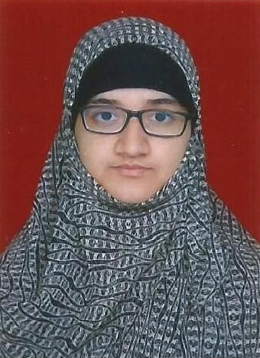

|  |  |
| --- | --- |
| **Khan Sameen Rashid** | |
| Date of Birth : September 18, 1995 | |
| Address: | B/501, Habitat CHS, Plot No. A 46/47, Sector 23, Nerul (East), Navi Mumbai - 400706 |
| Contact No.: | 8976193246 |
| Email Id: | skldgr8.90@gmail.com |

**Education:**

|  |  |  |  |
| --- | --- | --- | --- |
| **Course** | **Year of Passing** | **University** | **Percentage** |
| Master of Arts (Clinical Psychology) | June 2017 | University of Mumbai | Completed 1 year |
| Bachelor of Arts (Psychology) | April 2016 | University of Mumbai | 73.33 |
| H.S.C (Science) | February 2013 | Maharashtra State Board | 54.83 |
| S.S.C | March 2011 | Maharashtra State Board | 87.64 |

**Work Experience:**

|  |
| --- |
| Currently working as a DMIT Certified Counselor with Minds Magic Edu.  Worked as a College Counselor with CART (Center for Assessment Remediation and Therapy) since August 2018 till November 2018.  Dealt with stress management, academic issues and behavioural issues.  Undertook seminars on various life skills.  Comfortable working with adults using PCT and REBT. |

**Achievements & Activities:**

|  |
| --- |
| Author of the novel titled, “The Aftermath”, published by Blackbuck Publications.  Secured two Academic Proficiency Awards in VESASC College, Mumbai for standing first in the TYBA University Examination and being the Overall Topper (all six semesters included) in the BA Examination [2015-2016] |
| Presented a Poster titled, ‘Role of Spirituality in Coping with Stress’ at an International Conference titled ‘Centenary Conference on Psychology’ organized by University of Calcutta, India [October, 2015] |
| Participated and won the Second Prize for ‘Psyc Sabha’ in an inter-collegiate Psychology event titled, ‘Psyc Insight’ by Jai Hind College, Mumbai [December, 2014] |
| Participated and won the Consolation prize for a speech on ‘Superstitions and the Indian Society’ organized by Karmaveer Bhaurao Patil College, Vashi and Aajchi Navi Mumbai Weekly [September, 2013] |
| Participated and won the Third Prize for Story Writing in the college event titled ‘Talentia’ by VESASC College, Mumbai [December, 2015] |
| Organized and participated in staging a ‘Street Play’ on ‘World Mental Health Day’ to emphasize the importance of Mental Health in the 21st Century [October, 2013] |
| Presided ‘Introspection - an Association of Students for Psycho-Social Development’ C/o Dept. of Psychology, Karmaveer Bhaurao Patil College, Vashi for the academic year 2014-2015- organized and participated in its various events. |
| Contributed as Student Volunteer for the VESASC college magazine ‘Vivek’ for two consecutive years, 2015-2016 and 2016-2017. |
| Contributed as Student Editor (English Section) to the college magazine ‘Ace Modernian 2014-2015’ [Karmaveer Bhaurao Patil College, Vashi] |

**Hobbies and Interests:**

|  |
| --- |
| Reading fiction and non-fiction. |
| Writing essays, articles, short stories and novels. |
| Interested in learning new things and working for social good. |